PYTHON-5
DICTIONARIES
1.Python Dictionaries
- Dictionaries are used to store data values in key:value pairs.
- A dictionary is a collection which is ordered*, changeable and do not allow duplicates.
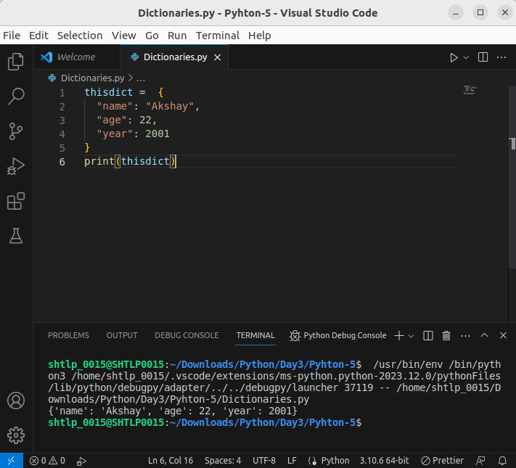
.

Dictionary Items
- Dictionary items are ordered, changeable, and does not allow duplicates.
- Dictionary items are presented in key:value pairs, and can be referred to by using the key name.
- As of Python version 3.7, dictionaries are ordered. In Python 3.6 and earlier, dictionaries are unordered.

- When we say that dictionaries are ordered, it means that the items have a defined order, and that order will not change
- Dictionaries are changeable, meaning that we can change, add or remove items after the dictionary has been created.

- Dictionaries cannot have two items with the same key

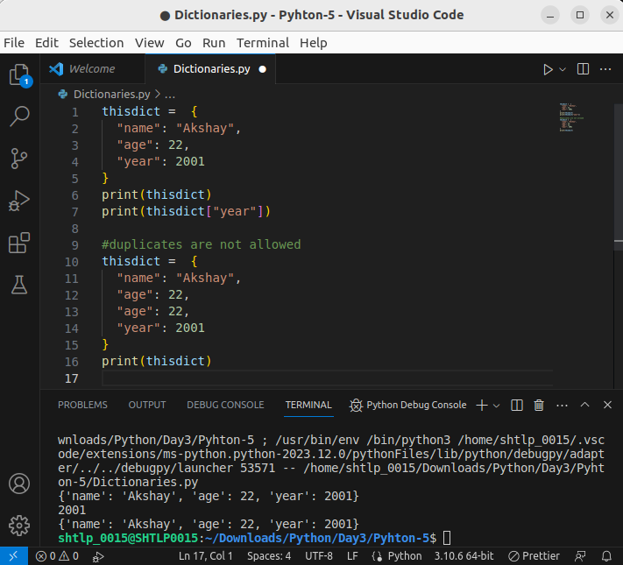
.

- To determine how many items a dictionary has, use the len() function:
- The values in dictionary items can be of any data type
- type() :From Python's perspective, dictionaries are defined as objects with the data type 'dict'
- It is also possible to use the dict() constructor to make a dictionary.
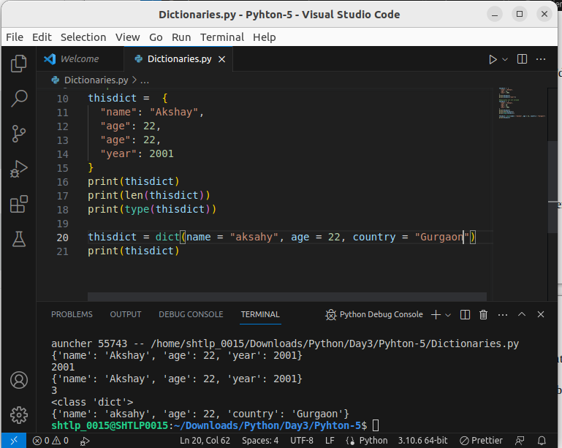

Python Collections (Arrays)
There are four collection data types in the Python programming language:
- List is a collection which is ordered and changeable. Allows duplicate members.
- Tuple is a collection which is ordered and unchangeable. Allows duplicate members.
- Set is a collection which is unordered, unchangeable*, and unindexed. No duplicate members.
- Dictionary is a collection which is ordered** and changeable. No duplicate members.

2.Access Dictionary Items
- You can access the items of a dictionary by referring to its key name, inside square brackets
There is also a method called get() that will give you the same result

Get Keys
- The keys() method will return a list of all the keys in the dictionary.
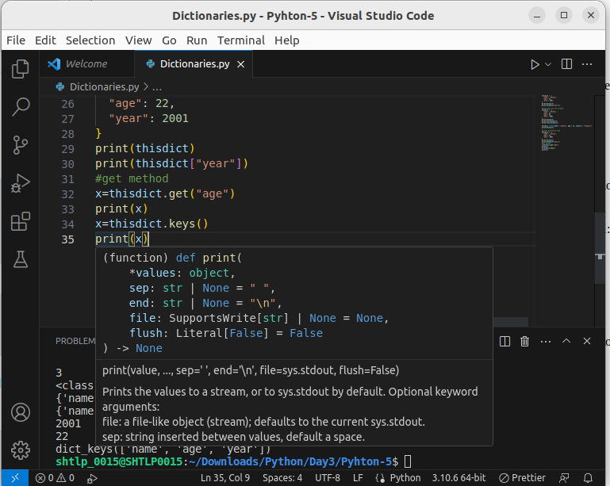
- The list of the keys is a view of the dictionary, meaning that any changes done to the dictionary will be reflected in the keys list.
- Make a change in the original dictionary, and see that the values list gets updated as well:
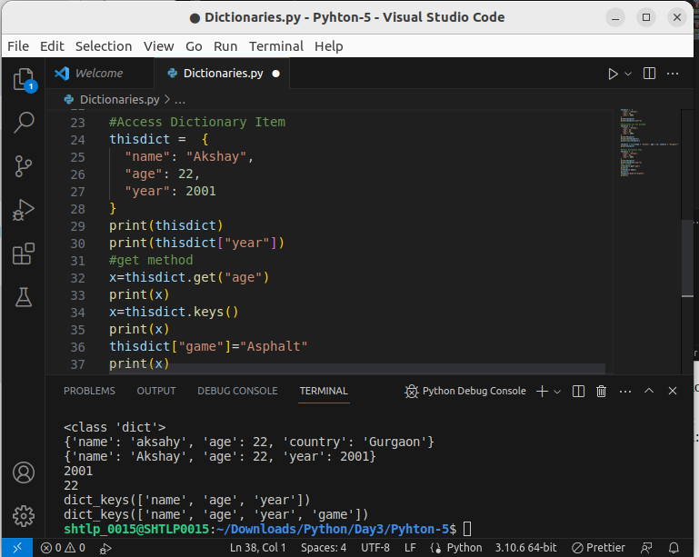

Get Values
- The values() method will return a list of all the values in the dictionary.
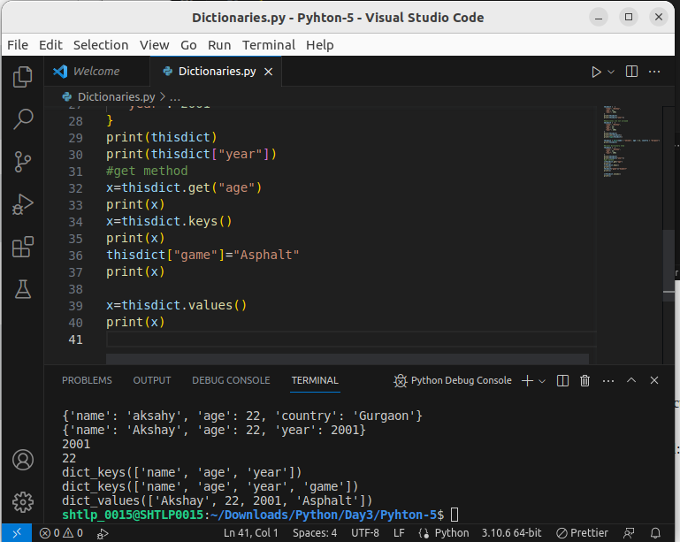
- The list of the values is a view of the dictionary, meaning that any changes done to the dictionary will be reflected in the values list.
- Make a change in the original dictionary, and see that the values list gets updated as well:
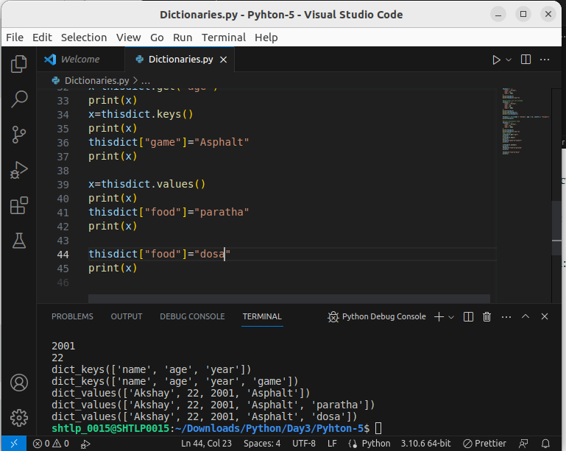
- Add a new item to the original dictionary, and see that the values list gets updated as well:
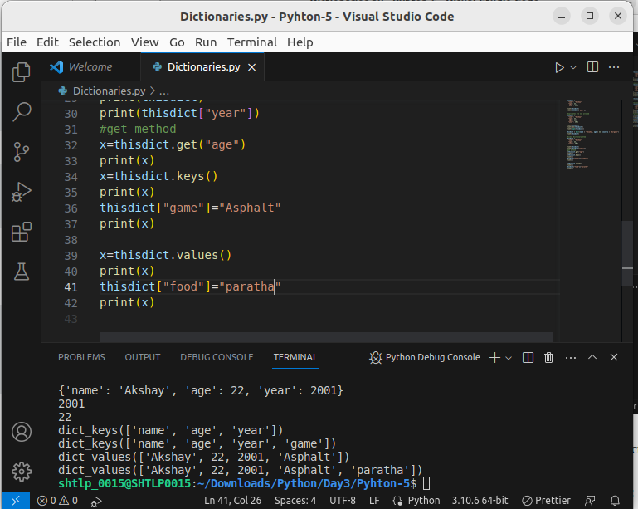

Get Items
- The items() method will return each item in a dictionary, as tuples in a list.
- Get a list of the key:value pairs
- The returned list is a view of the items of the dictionary, meaning that any changes done to the dictionary will be reflected in the items list.

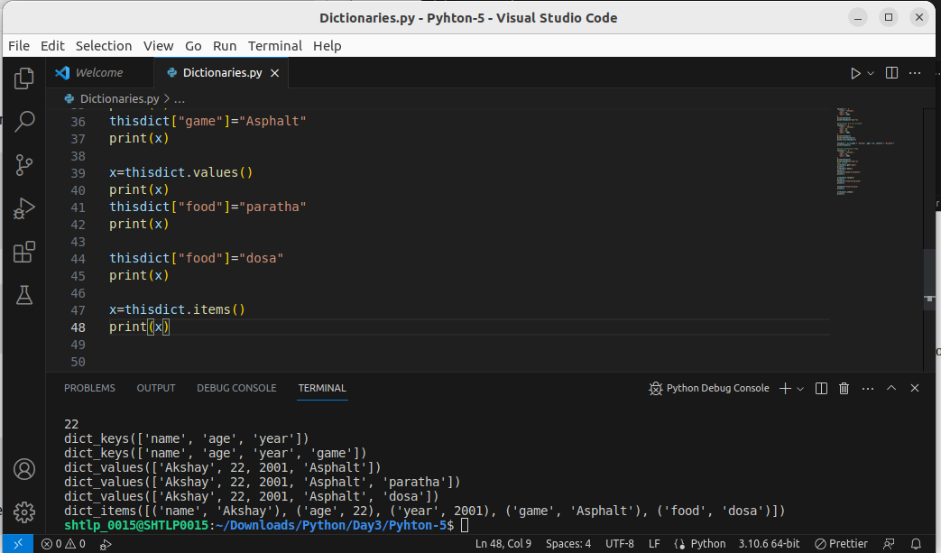
- Add a new item to the original dictionary, and see that the items list gets updated as well:
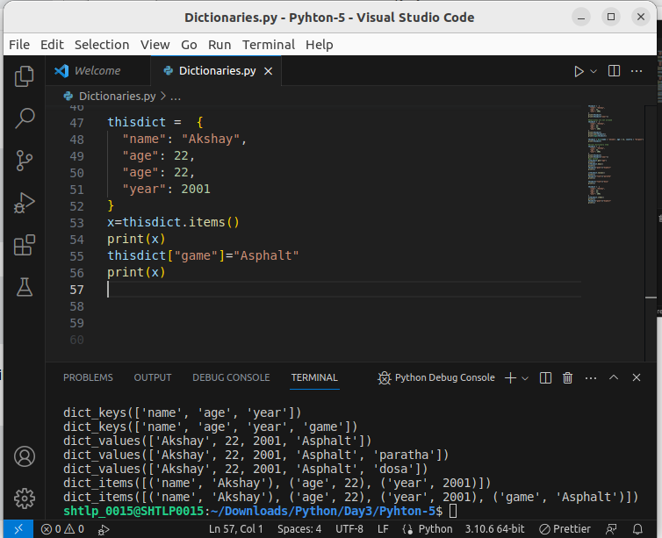

Check if Key Exists
- To determine if a specified key is present in a dictionary use the in keyword:
- Check if "model" is present in the dictionary

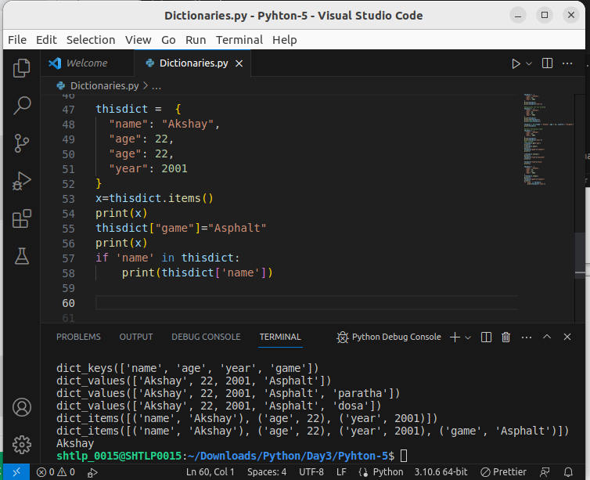
.

Change Dictionary Items

Change Values
- You can change the value of a specific item by referring to its key name:
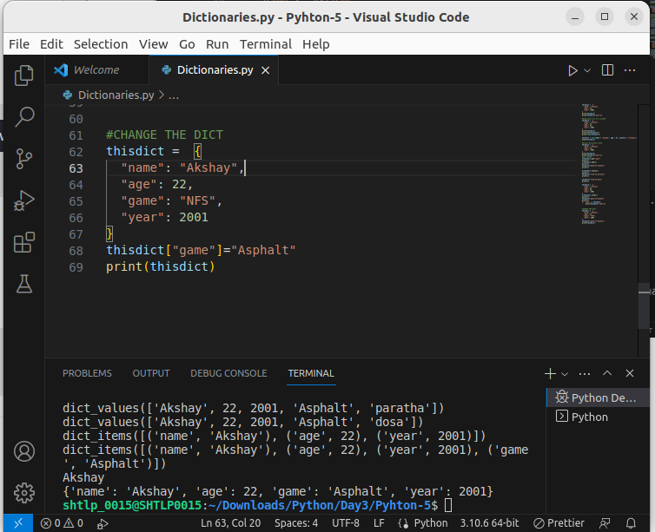
.

Update Dictionary
- The update() method will update the dictionary with the items from the given argument.
- The argument must be a dictionary, or an iterable object with key:value pairs.
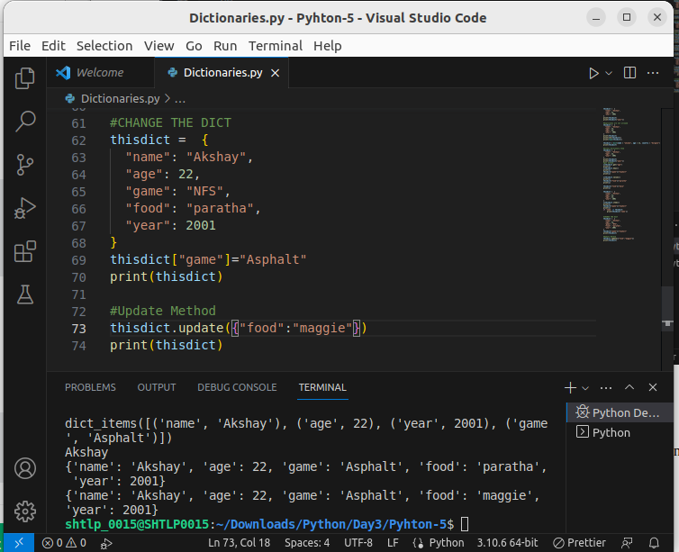
.

Add Dictionary Items

Adding Items
- Adding an item to the dictionary is done by using a new index key and assigning a value to it:

Update Dictionary
- The update() method will update the dictionary with the items from a given argument. If the item does not exist, the item will be added.
- The argument must be a dictionary, or an iterable object with key:value pairs.

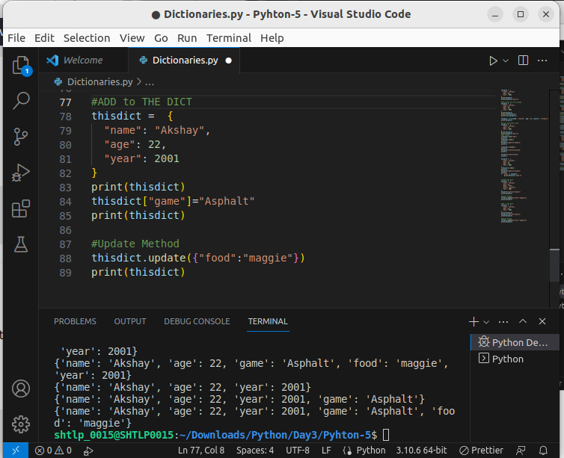
.

Remove Dictionary Items
- The pop() method removes the item with the specified key name
- The popitem() method removes the last inserted item (in versions before 3.7, a random item is removed instead)
- The del keyword removes the item with the specified key name
- The clear() method empties the dictionary

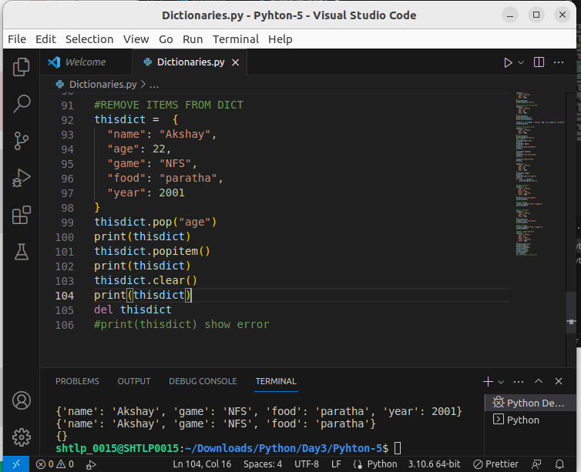
.

Loop Dictionaries
- You can loop through a dictionary by using a for loop.
- When looping through a dictionary, the return value are the keys of the dictionary, but there are methods to return the values as well.
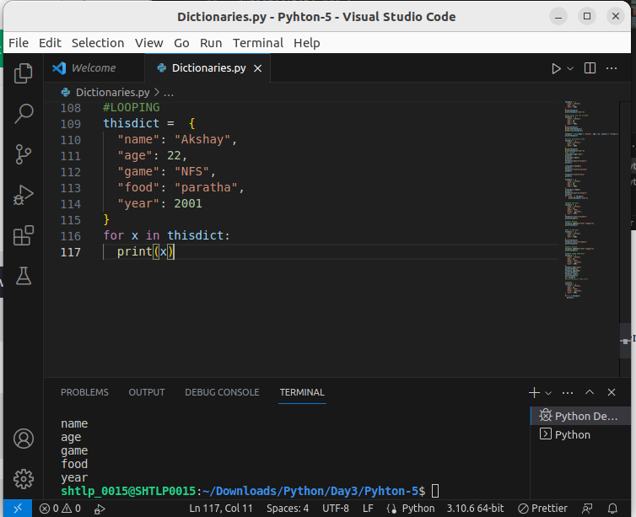
.
- Print all values in the dictionary, one by one:

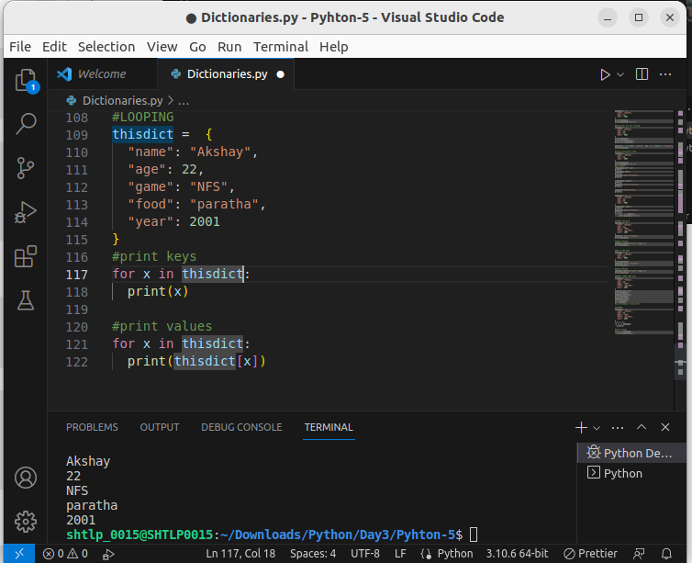
.

- You can also use the values() method to return values of a dictionary:

- You can use the keys() method to return the keys of a dictionary:

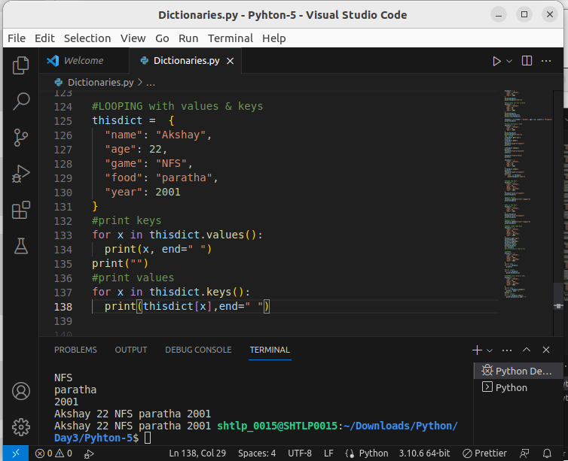
.

- Loop through both keys and values, by using the items() method:

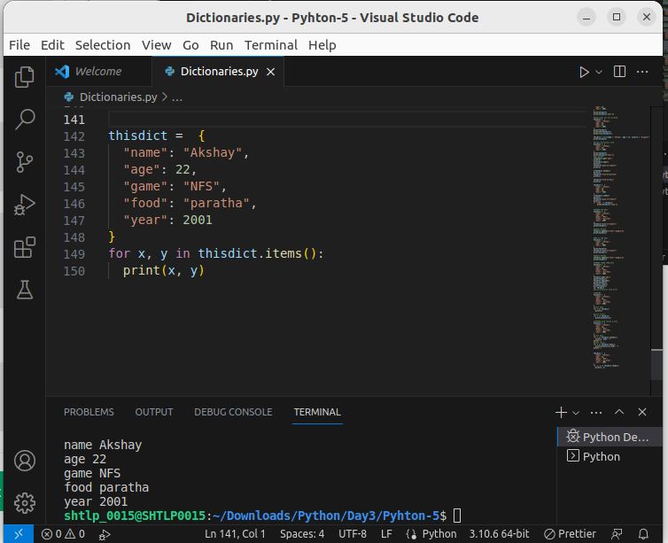
.

Copy a Dictionary
- You cannot copy a dictionary simply by typing dict2 = dict1, because: dict2 will only be a reference to dict1, and changes made in dict1 will automatically also be made in dict2.
- Make a copy of a dictionary with the copy() method
- Make a copy of a dictionary with the dict() function:
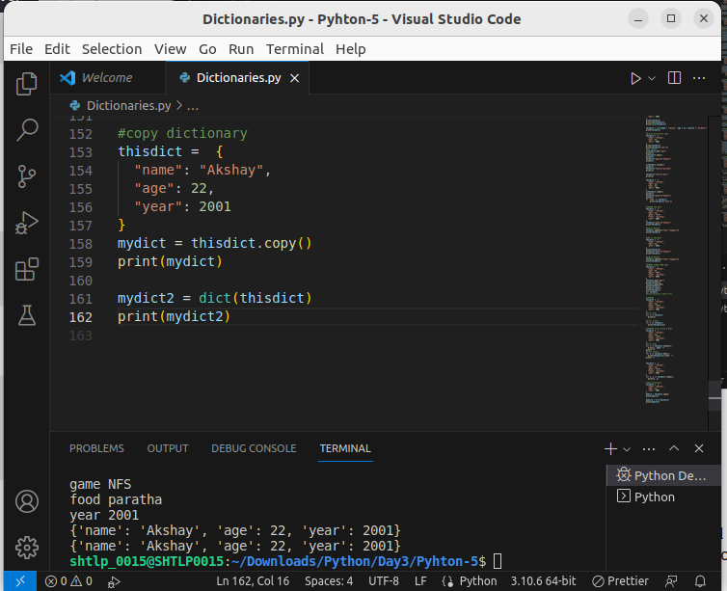
.

Nested Dictionaries
- A dictionary can contain dictionaries, this is called nested dictionaries.



